DBOX Credit card and ACH

processing

Document Approval
Approver | Approved Date | Rejected Date | Comments

Part 1 Functionality Overview

Objectives (Why are we doing this?)
To enhance the self-service role the DBOX system provides, it is desired to provide a method of selecting open invoice(s) to pay via credit card and electronic payments (ACH, EFT, eCheck).

Enhancement phase 1–
Utilizing core credit card processing and ACH capabilities, have an unpaid invoice, credits, and unapplied payments selection screen available on the customer roles within DBOX (under the transactions or customer summary area) that would allow a user to select single or multiple invoices, credits, and unapplied payments to apply to the payment. When the pay button is selected it will prompt for payment via electronic payment.
Conditional formatting. The invoice line will be bold or other color if not opened.
Once payment has been processed a “statement of payment” will be generated and emailed to the user logged in automatically or alternatively the system will automatically display the report upon successful payment for the user to print/download.
After the report screen is closed, it will return to the unpaid invoice selection screen and auto refresh for unpaid invoices.
Electronic payment should apply against invoice to clear AR. There will be no leftover amount as we will not initially support partial payment of an invoice. Only full amounts will be applicable payments.
Enhancement Phase 2
If choosing to pay invoice by credit card, prompt the user to accept or decline a service charge fee that will be added to the invoice. ACH would not get this service charge. If the user declines service charge, then it will just return to the unpaid invoice screen.
This fee would need to be broken out as a separate column on the payments screen in financials and DBOX payments screen for viewing. A special “cc fee” item will need to be set up with associated category to track in separate GL
There will need to be a bit field on the customer account to indicate whether this CC transaction fee is applicable to the customer or not. If it is a good customer, the fee is waived and would not affect the customers payment via credit card (e.g., don’t calculate or show)
Enhancements Phase 3
If choosing to pay via ACH, early payment terms may exist (e.g., 2% net 10) This discount should be considered when presenting the amount to pay via ACH. The discount available would need to be broken out as a separate column on the payments screen in financials and DBOX payments screen for viewing. If the discount is not available, the discount will display zero. Credit card payments do not have early payment discounts available, and the full amount should be processed plus CC transaction fee.

User Roles and Responsibilities

- A valid CC processing subscription to Authorize.net
- ACH subscription through authorize.net
- Maintain numeric field on customer account to assess CC processing % fee or not
- Setup of item and category to represent CC processing fee
- Customer training

Part II – Functional Requirements

Proposed screen layouts
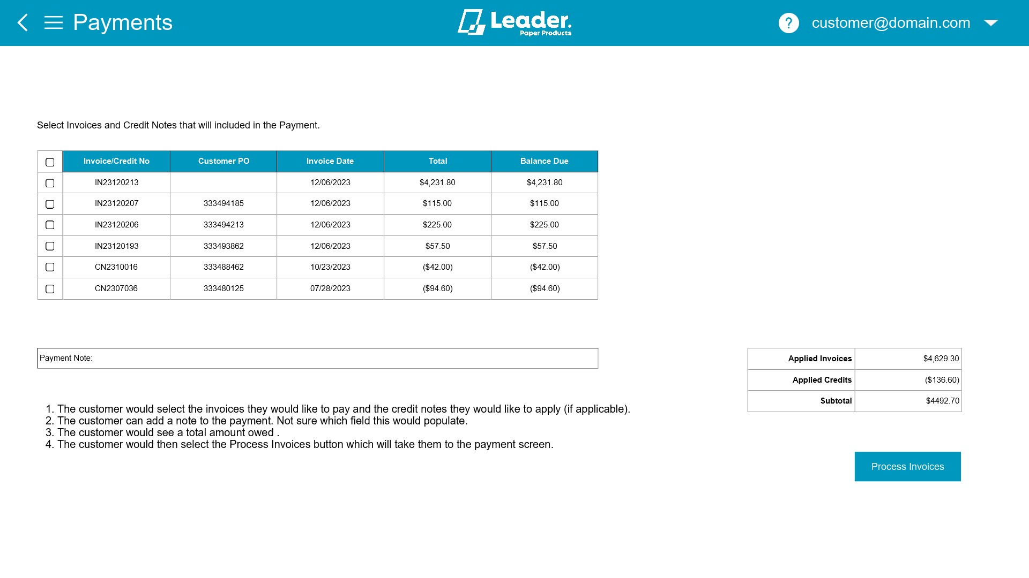

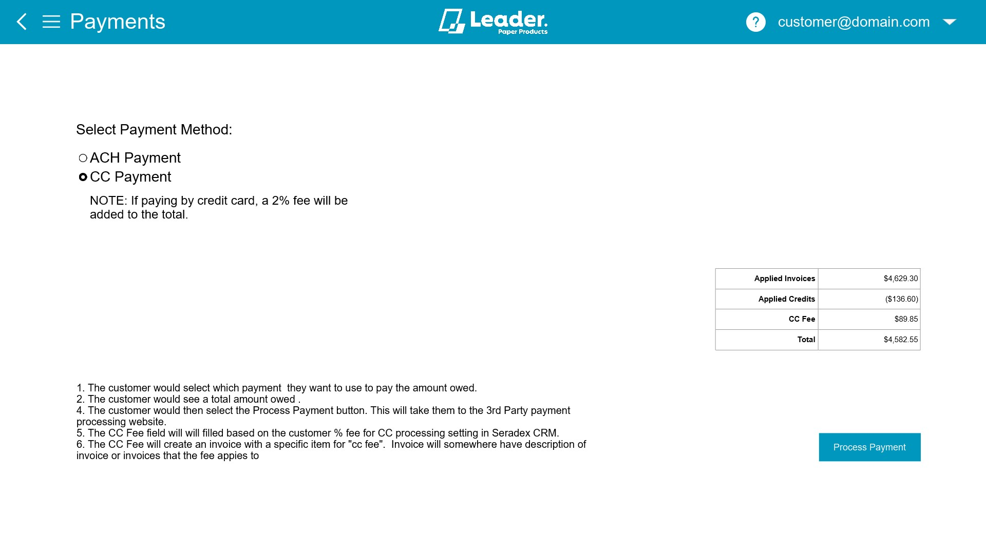
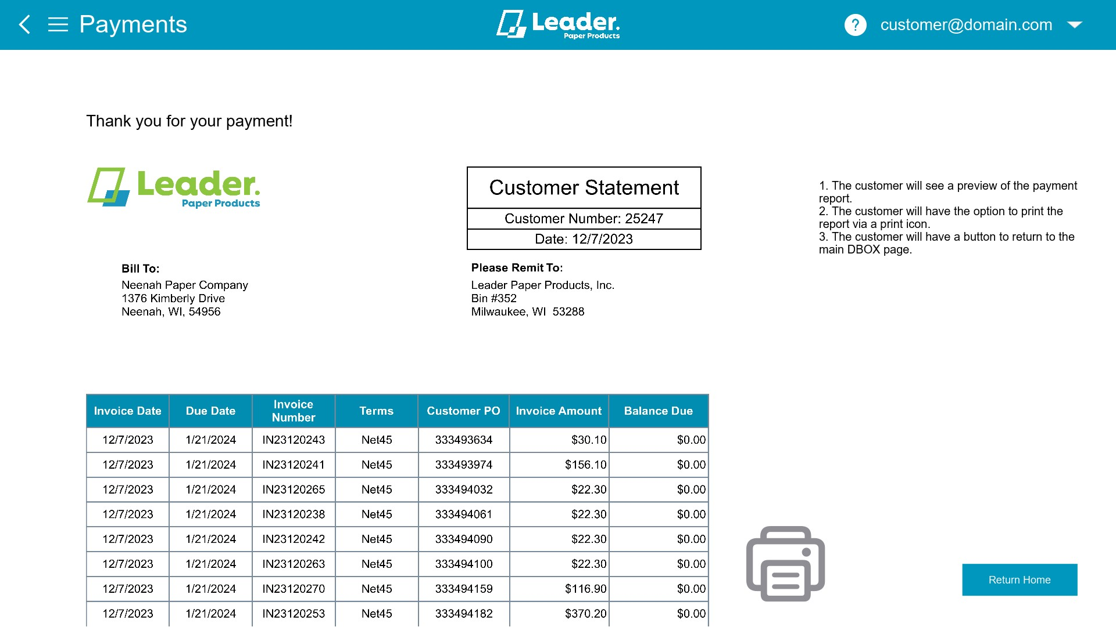

Excel mockup with comments on fields

Part III – Change Order Details

Date | Enhancement | Requested By | Notes | Priority | Release Status

